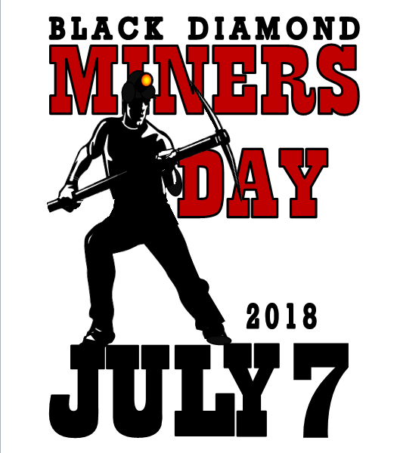

2019

JULY 13th

Celebrating 100 Years of Women’s Suffrage

MINERS DAY CONTACTS
Tori Ammons, Miner’s Day Chair 253-205-1734 blackbearoutpost2@gmail.com Keith Watson, Booths 425-214-3684 kcwdoc@comcast.net
Steve Israel, 5K Run 253-350-8490 homecareconst@comcast.net
Gina Vaughan, Sponsorships 360-886-9293 smokehouseandmore@yahoo.com Tracey Prociw, Advertising, Signage 253-561-9002_______tprociw@soundpublishing.com

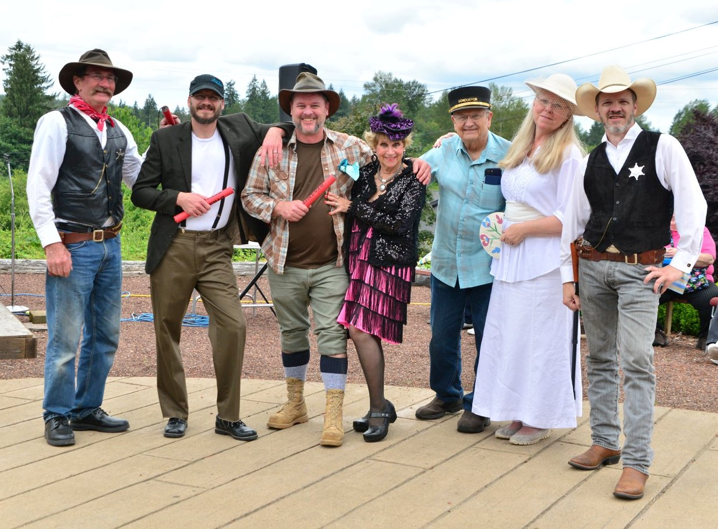

KING COAL SPONSORSHIP $1,500

Logo featured in all media/advertising including:
- Name on 11x17 posters, 100+
- Name & Logo in print/web advertising
- Logo on 2 street banners
- One Booth position @ street fair in Historical BD
- Choice of event sponsorship
- Sign w/name & logo located by event
- Live announcements during events

COAL CART SPONSORSHIP $500
- Name on 11x17 posters, 100+
- Name & Logo in print/web advertising
- Choice of event sponsorship
- Sign w/name & logo located by event
- Live announcements during events

COAL NUGGET SPONSORSHIP $250 (or payment in-kind)

Name on 11x17 posters, 100+
- Name & Logo in print/web advertising

2019
EVENTS TIED TO SPONSORSHIPS

- Vintage Theater
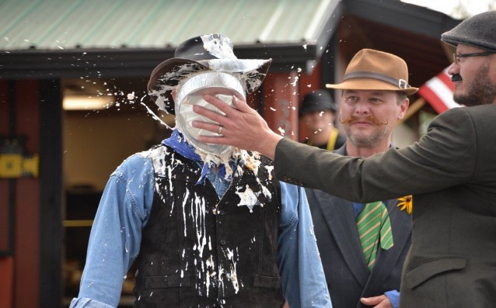
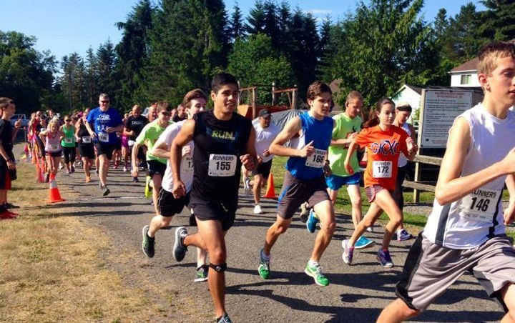
- Coal Miners Classic 5k Run

- Donut Eating Contest

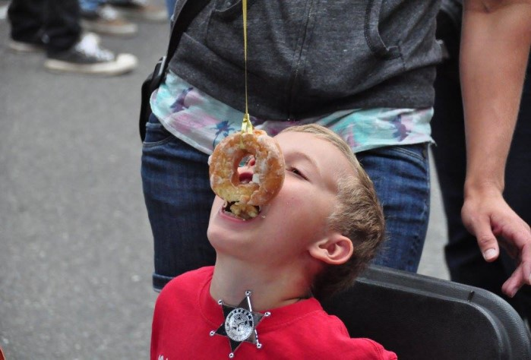
- Artists Chalk-In Competition

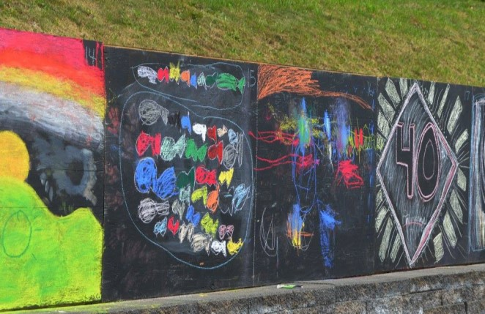
- Children’s Craft Booth
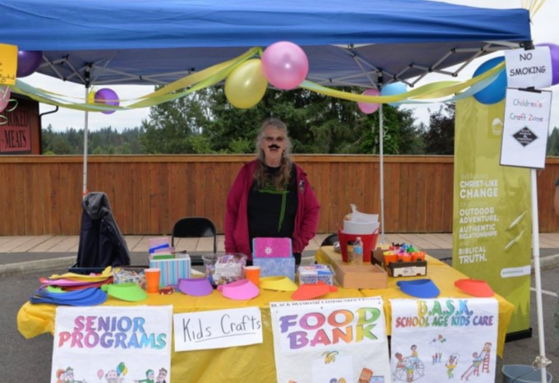

- Event and Staff T-shirts
- Stage Platform for Bands

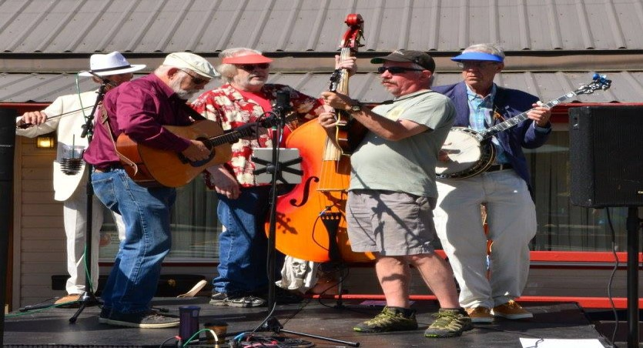
- Vintage Fashion Show

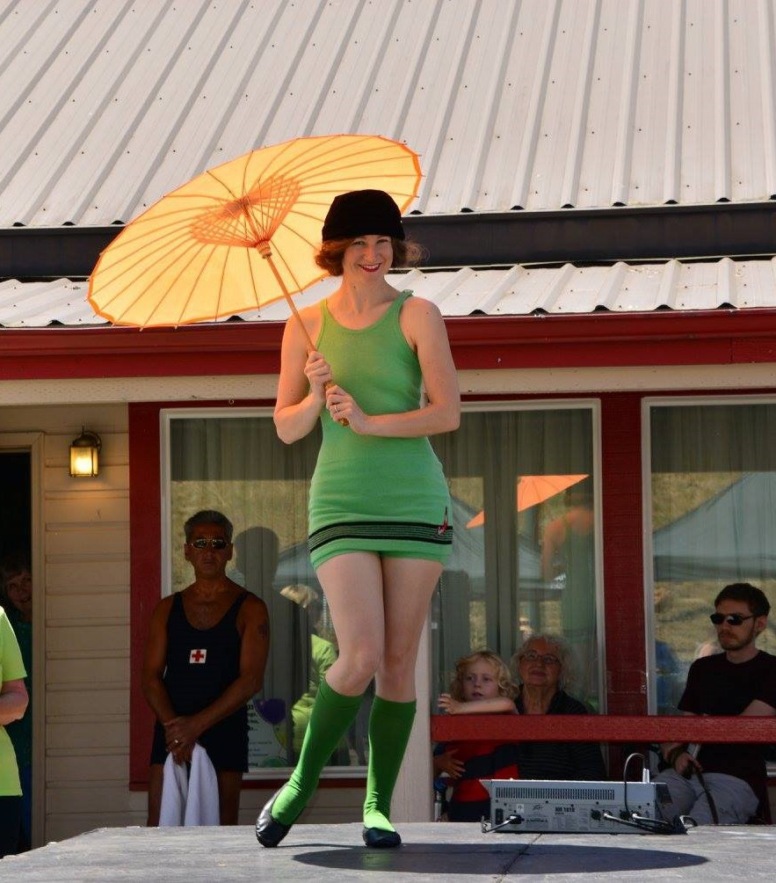

- Children’s Show

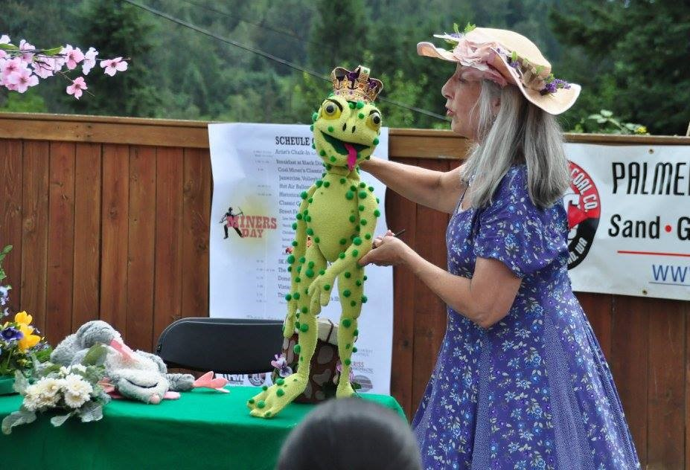
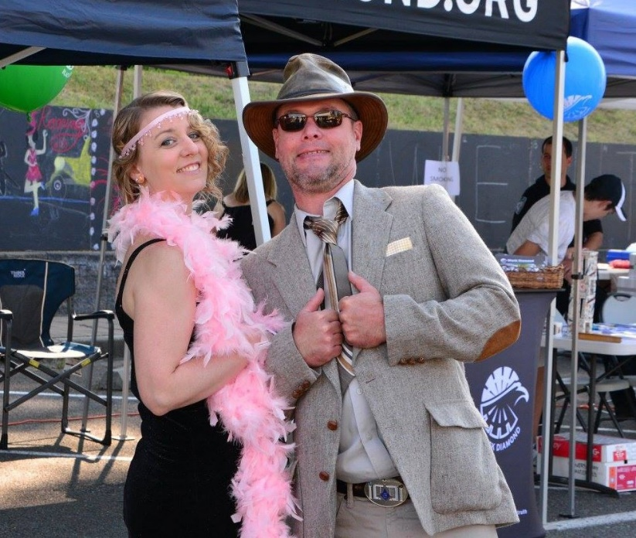
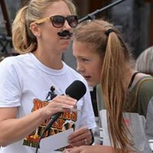
Perhaps you would like to introduce
a new activity this year…..!!!
  - Barbershop Quartet
  - Mule Rides
  - Bail from Jail fundraiser

SPONSORSHIP AGREEMENT & INVOICE

(Company Name) (Date) Address

E-mail Phone Owner/Representative/

KING COAL Sponsorship COAL CART Sponsorship COAL NUGGET Sponsorship Other:
$1,500
$500
$250 or Payment In-Kind

Sponsor agrees to host the following activity as described:

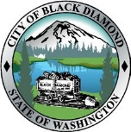
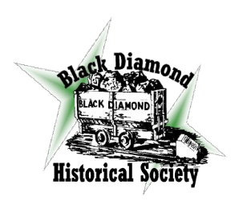
Black Diamond Historical Society & Museum is a non-profit 501(c)3 Corporation established under IRS #51-0170304
Phone: (360) 886-2142
Please submit payment by June 30, 2019
BDHS (Black Diamond Historical Society)
PO Box 567, Black Diamond, WA 98010
Payments may be made to:
Invoice Date
Amount Due
THANK YOU FOR BEING A PROUD SPONSOR
OF BLACK DIAMOND MINERS DAY. WE APPRECIATE YOU!

Black Diamond miner’s Day Booth Exhibit
Booths will be on BOTH SIDES OF Railroad Avenue
July 13, 2019
BOOTH APPLICATION and Contract

Company Name Date | Booth Number
Contact Name Phone
Address | Date Paid
City State Zip

Booth Size Request: [ ] 10x10 ft ~ Qty [ ] 10x20 ft ~ Qty

Note: you will need to provide your own power if needed.

FEES: [ ] All Booths (10X10) ……… $40.00 OR (10X20).......$80.00 Make checks out to: MDBDHS & mail to below address [ ] Non Profit … $25 Non-Profit ID # (cannot process w/o number)
Briefly describe all your product or Services to be sold Home Based? Y / N

If selling food products check with King County for Permits (check exempt foods & low cost plan only foods)
http://www.kingcounty.gov/healthservices/health/ehs/foodsafety/foodbusiness.aspx For Health Permit Needs

*Items not allowed are: political booths, alcoholic beverages, stink bombs, fake cigarettes, fart spray. Fireworks, weapons, (I.e. knives, cap guns, pocket knives, whips etc.) Items inappropriate for a family event or which create a mess on the festival grounds cannot be sold at Black Diamond Miner’s Day.
Application Deadline June 30th, 2019

In signing this agreement, applicant agrees to comply with all festival, state, and local regulations, to save and hold harmless the City of Black Diamond, the Black Diamond Miner’s Day Committee, their officers, employees, sponsors and agents from any loss or damage to any persons or property cause by the applicants operations in connection with the Black Diamond Miner’s Day Celebration and further agrees to defend said Associations and the City for any claims for such damage. I have read and understand the Exhibitor Agreement and Liability Statement and will abide by them throughout my association with the Black Diamond Miner’s Day Event.
Merchant Signature Date / /

Print Name Title Phone
Address Email

Your Insurance Companies Name Policy#

Please sign contract/application & Statement Agreement before mailing to the below address:

Mail to: PO Box 567 Black Diamond, WA. 98010-0567 c/o Keith Watson 360-886-0778 kcwdoc@comcast.net

A cashed check is your receipt page 1 of 2

Black Diamond Miner’s Day Celebration July 13, 2019
Exhibitors Agree to run their own booths and set up in a timely manner. If Exhibitor is not set up 30 minutes before festival hours, 9:00 AM Saturday July 13, the booth chairman may sell their space to another exhibitor. There is no refund of booth fees. Exhibitors are required to collect Washington State Sales Tax, which is .086%. If you do not have a tax number or need a tax schedule, contact the Washington State Dept. of Revenue.
Exhibitors Agree to pay the appropriate booth fee, see application. Booth fee are non- refundable within two weeks of even and subject to a 25% handling fee. Please keep your display dimen- sions within your allotted space and not encroach upon space assigned to another exhibitor.
Exhibitors Agree to provide equipment for display of their own merchandise, booth covers, tables, etc. Sun can be a problem as well as rain. Be prepared for inclement weather.
Exhibitors Agree to describe your product or services. As well as provide pictures of the product. If it is dif- ferent than what was represented, you may be asked to remove it, items deemed inappropriate for a family event or which create a hazard cannot be sold at BD Miners Days. Items not allowed are: Alcoholic Bever- ages or Products, stink bombs, fake cigarettes, fart spray, fire works, weapons, (i.e. knives, cap guns, swords, pocket knives, whips etc.)
Exhibitors Agree to use booth space in a reasonable and non-offensive manner subject to public health and safety regulations and subject to these rules and regulations of the celebration. No hawking is allowed.
Exhibitors Agree to clean their booth sites and surrounding areas during and at the end of the celebration as well as leaving their area clean after tear down.
Exhibitors Agree to remain open during festival hours, rain or shine. No tear down will be allowed until af- ter close of the festival Saturday afternoon at 4:00 pm or advised by chairman.
Exhibitors Agree to refrain from consuming drugs or alcohol on the show premises and to comply with all festival, State and local regulations. No Firearms, Drugs or Alcohol are allowed on property.

Liability Statement
Black Diamond Miner’s Day officials reserve the right to restrict or remove exhibits without refund that may have been falsely entered or deemed by the officials to be unsuitable or objectionable. This re- striction applies to noise, music, persons, animals, birds, things, conduct, printed matter or anything that might be objectionable to the officials.
Exhibitors will assume responsibility for their own merchandise and display equipment and will hold harmless the City of Black Diamond, the Black Diamond Miner’s Day their officers, employees, sponsors, and agents from any loss or damage to any persons or property caused by the applicants operation in con- nection with the Miner’s Day Celebration and further agrees to defend said Associations and the City for any claims for such damage.
Food vendors assume all responsibility for their product and must package and sell according to all applicable State and local ordinance, which apply.
The Black Diamond Miner’s Day Celebration and its Agents, will not be held responsible for loss of sales due to inclement weather, natural disaster, legal restriction or ordinance, unlawful acts or acts of God. The Black Diamond Miner’s Day Celebration does not guarantee sales.

Exhibitors signature of agreement to above statements
Page 2 of 2
Rev. 3/19

